ECE 3027 Electronics Laboratory – Lab 4

**Questions:**

1. What is the derivative and integral of y=1.

Derivative: 0   
Integral: x + C

1. What is the derivative and integral of the delta function.

Derivative: Doublet function

Integral: unit impulse

1. What is the derivative and integral of the sine function.

Both are the cosine function.

1. Working in the frequency domain, and using the inverting amplifier as a model, find the transfer functions of the Integrator and Differentiator circuits, shown below. It may help to start with the ideal transfer function of the inverting amplifier: Vo/Vin = -R2/R1. Replace R2 and R1 with R and the impedance of a capacitor, 1/sC.

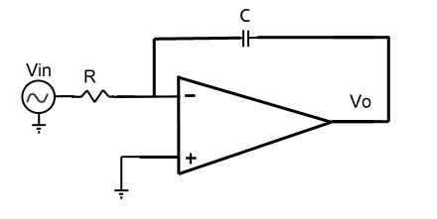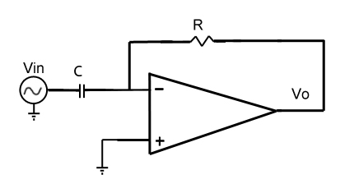

Differentiator

Integrator

Inverting Amplifier

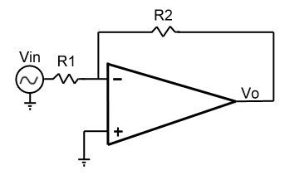

-R2/R1 -(1/sC)/R = -1/sCR -R/(1/sC) = -sCR

1. Multiplying by S in the frequency domain is equivalent to what operation in the time domain?

Integration

1. Dividing by S in the frequency domain is equivalent to what operation in the time domain?

Differentiation

1. (Repeated from Lab 3) What is the value of GND when the board is connected in single supply?

**Section 1: Differentiator**

**Preparation:**

This lab will use the differentiator to demonstrate that they work in dual and single supply.

As one would expect, differentiators will take an input Vin and produce a signal Vo that is the derivative of the signal, with a certain multiplier on the amplitude of the output voltage that depends on the values of the passive components in the circuit.

**Note that the circuit will always be inverting**, meaning that the output curve will be flipped from true integration and differentiation, and the amplitude of the output will have a factor of RC.

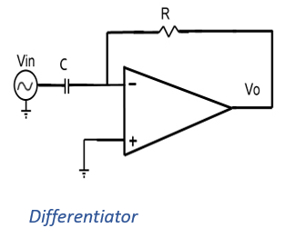

**Lab:**

**Observation:**

Dual Supply:

Build the differentiator circuit, refer to the schematic above. Do the experiments in **dual supply** first.

Set the function generator to **square wave** and observe the output.

Take a picture of the output and paste it here. Briefly explain your result.

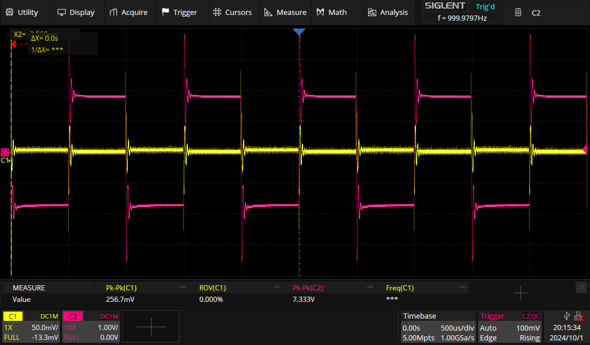

C2 is the output from the oscillator, C1 is the differentiated output.  
As shown in the picture, the differentiated square wave shows pulses only on the rising and falling edges of the square wave.

**Ringing:**

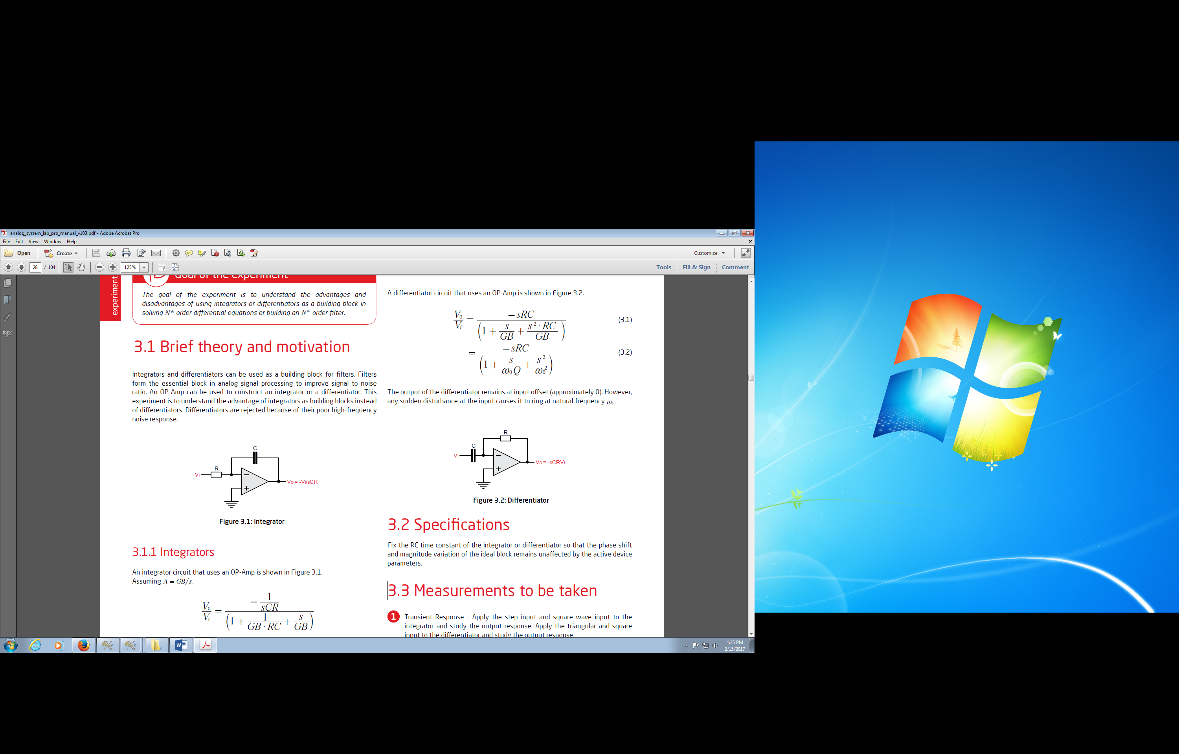The equations to the right show the non-ideal equations for the integrator and differentiator circuits, respectively, where “GB” stands for “gain bandwidth,” a constant for an op amp that is equal to the gain of its circuit times its bandwidth. You will learn more about these equations in 3020 and other circuits classes, but for now, keep in mind that a finite gain means that at higher frequencies, both circuits will incur phase shifts, and that for the differentiator, higher frequency inputs will cause “ringing,” the frequency of which is indicated in the equation as “”.



In the differentiator circuit, measure the ringing frequency and number of ringing cycles (estimate) for at least 2 different circuit designs. Record your measurements for two different R-C combinations. **(Note: you might need to try a few combinations of R and C before you see any ringing.)**

Ringing will appear at the transition of the square wave from low to high. You will probably need to zoom in.

R: 1K C: 0.1uF ringing f: 55.556kHz, ~4.5 cycles R: 2k2 C: 1uF ringing f: 10.64kHz, ~7 cycles

**Measure Charge Rate:**

For the differentiator, measure the time rate of change of the capacitor voltage (dVc/dt) right as the square wave input changes. **You can see this change on the oscilloscope by probing the V- op amp input.** Do this measurement for two different values of feedback resistor. Use Ic = C*dV/dt to calculate the charging current for each resistor value.

C = 0.1uF

Rf = 1k Ic = -0.242mA Rf = 2k2 Ic = -0.110

Single Supply:  
Change the power connections to the kit board to single supply (~9v): put the top rail (+10) at the higher voltage and the bottom rail (-10) at the lower voltage. Leave the board ground unconnected.

Repeat the square wave differentiator experiment with the board in single supply. Note that the ground reference for the circuit must be at the **mid rail (not the “-10V” connection as done in lab 3).** Adjust your source DC offset so that the voltage swing is between the rails and/or keep a low amplitude on the input peak to peak voltage. Briefly comment on your similarities and/or differences between your single supply differentiator and the dual supply.

**NOTE**: No need to perform ringing and charge rate in single supply mode.

Comments:

Neither wave is as clean in transition, and there is a notable lack of ringing at the transitionary point.

**Simulation:** Download differentiator circuit from Lab-4 folder and perform simulations. Change Rs, Cs to the ones available on board. Try to show input as well as output in the plot. Square wave input is already included in the schematic. First, run simulation in transient mode and observe the output. You should see noise at the output, which is normal in case of differentiator. Now change the input signal (amplitude, frequency=1/time period), Rs and Cs one by one and observe the change in output. Paste at least three simulation snapshots below, one of which should be with default circuit values. No need to observe the ringing in simulation, the noise you will see is the ringing. Write a short note on your observation.

NOTE: Perform simulations in dual power supply you use on board.

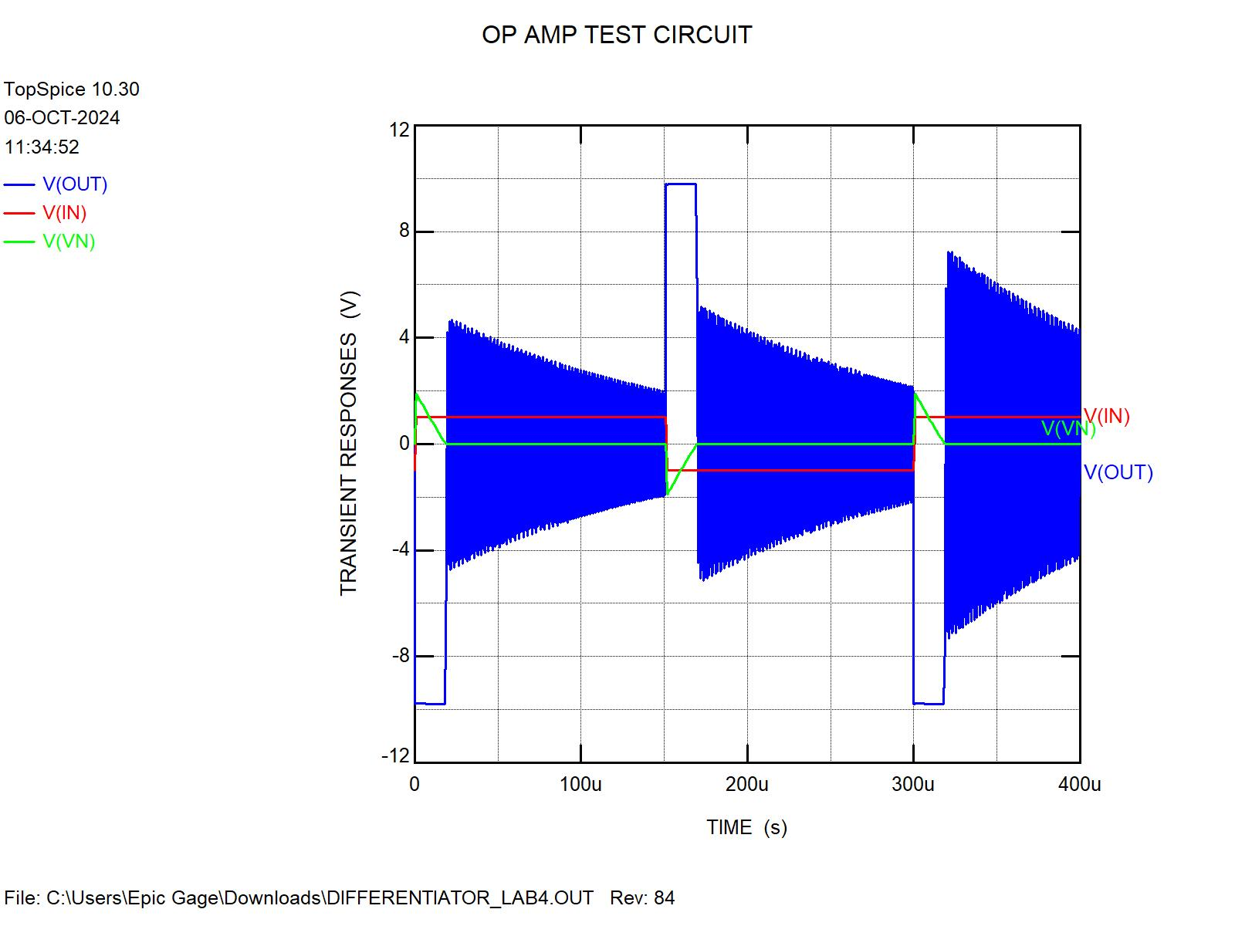

The ringing is most intense at the rising edge of the input signal, but also seems to increase as more clock cycles occur.

**Section 2: Integrator**

**Preparation:**

This part of the lab will use the integrator circuits to demonstrate that they work in dual and single supply.

As one would expect, integrators will take an input Vin and produce a signal Vo that is the integral of the signal with a certain multiplier on the amplitude of the output voltage that depends on the values of the passive components in the circuit.

This experiment is to understand the **advantage of integrators as building blocks instead of differentiators**. Differentiators are rejected because of their poor high-frequency noise response.

**Note that this circuit will always be inverting**, meaning that the output curve will be flipped from true integration and the amplitude of the output will have a factor of RC. Another important thing to note is that, because of the nature of integration, the integrator specifically will be very sensitive to the operating point of the input wave form, such that even one mV change in this bias will cause the output waveform to travel up to settle at the top rail or down to settle at the bottom rail.

**Lab:**

**Observation:**

Dual Supply:  
Build the integrator circuit. Refer to the schematic from Questions section above. Do the experiment in **dual supply** first.

Set the function generator to **square wave** and observe the output of integrator circuit.

Take a picture of the output and paste it here. Briefly explain your result.

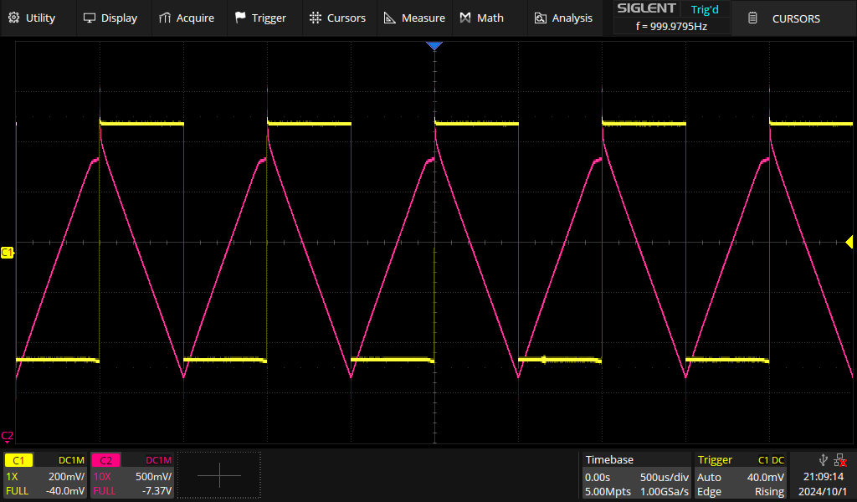

As you can see above, the integrated signal almost becomes a triangle wave, in which the slope is discontinuous.

**Applying a Sine Wave:**

1. Apply a sine wave input.
2. Change the input frequency and observe the output for the integrator circuit.
3. Record the phase shift for different frequencies in the blanks given below.
4. You can calculate the phase shift based on the time difference between peaks of input and output signals and divide that by period of the signal.

Hint: what is the integral and derivative of sine?

**Integrator**: Input f: 100 Hz phase shift: π/4 Input f: 2kHz phase shift: π/4

Single Supply:

Change the power connections to the kit board to single supply (~9v): put the top rail (+10) at the higher voltage and the bottom rail (-10) at the lower voltage. Leave the board ground unconnected.

Repeat the square wave integrator experiment with the board in single supply. Note that the ground reference for the circuit must be at the **mid rail.** Adjust your source DC offset so that the voltage swing is between the rails.

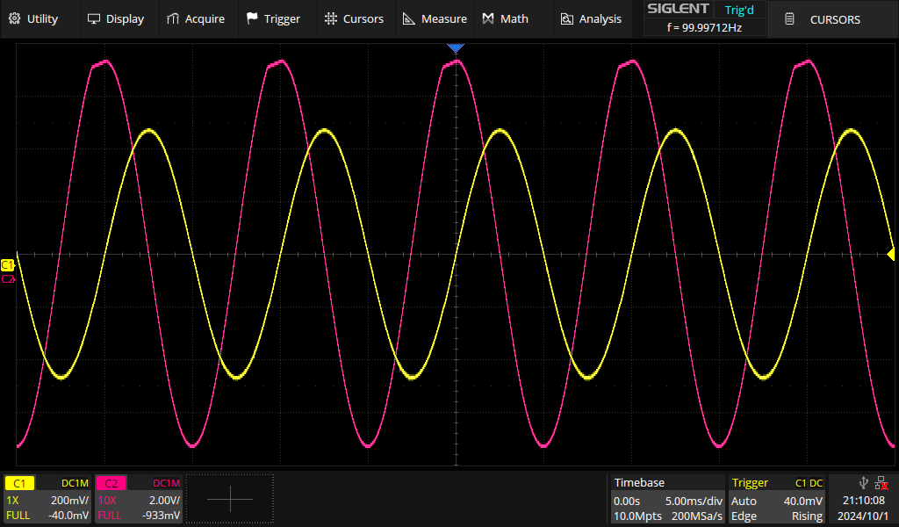

Comments: The phase shift of the sine wave is 90 degrees, and due to the chosen resistor and capacitor values the amplitude also increases.

**Simulation:** Download integrator schematic from Lab-4 folder and perform simulations. Change Rs, Cs to the ones available on board. Try to show input as well as output in the plot. Square wave input is already included in the schematic. First, run simulation with default values of circuit components in transient mode and observe the output. Second, change the input signal (amplitude, frequency=1/time period), Rs and Cs one by one and observe the change in output. Paste at least three simulation snapshots below, one of which should be with default circuit values. Third, change the input voltage source to sinusoidal wave, run the transient simulation and paste one snapshot of this simulation. Write a short note on your observations for both type of inputs.

NOTE: Perform simulations in dual power supply you use on board.

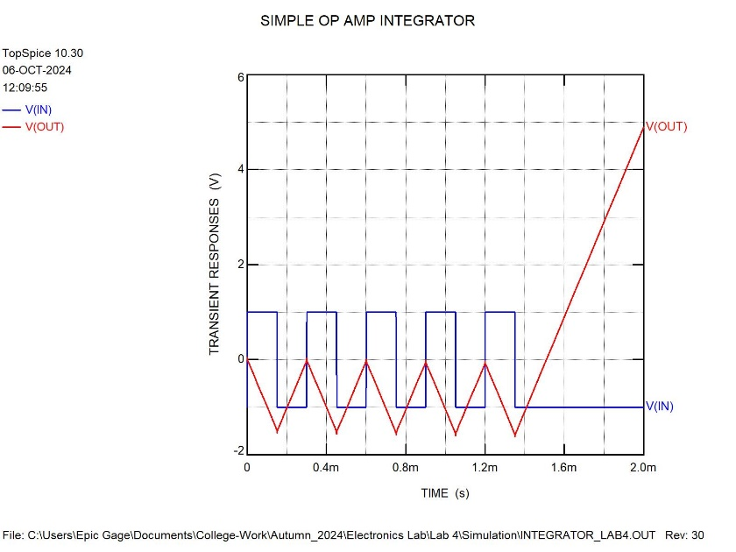 Default – 1k resistor, .1uF capacitor

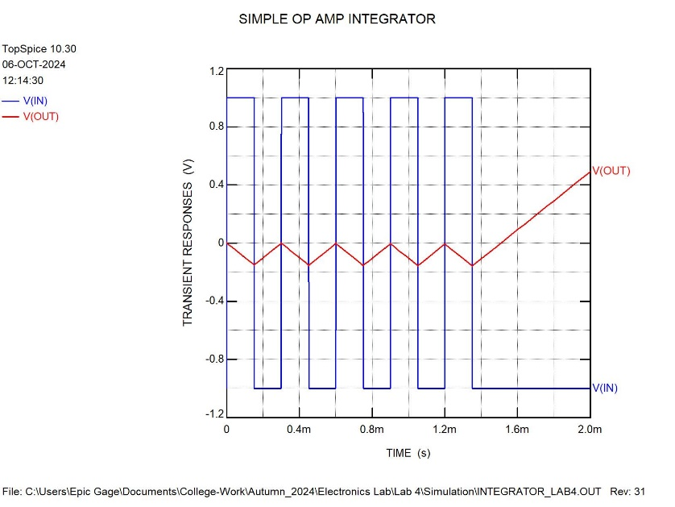 10k resistor

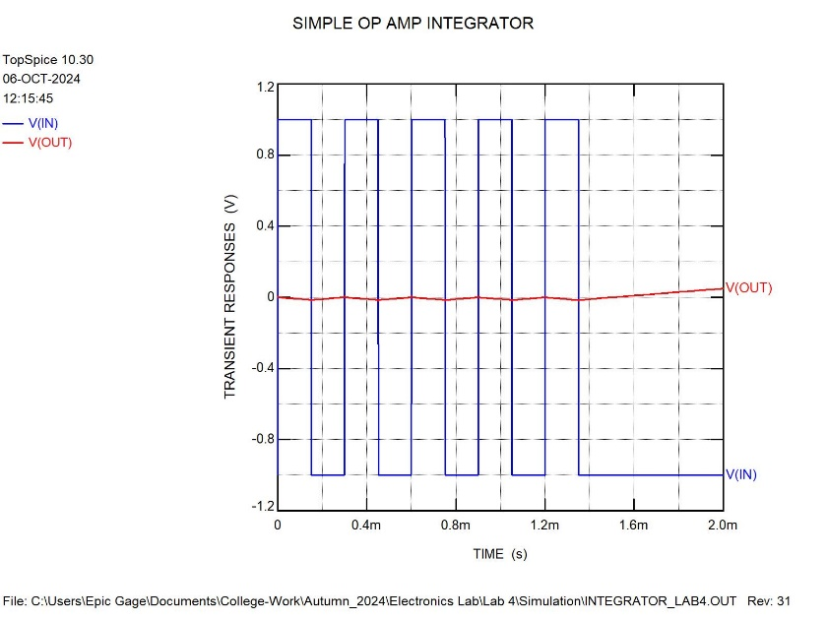 1uF capacitor